Principles of Stratigraphy

Introduction Question
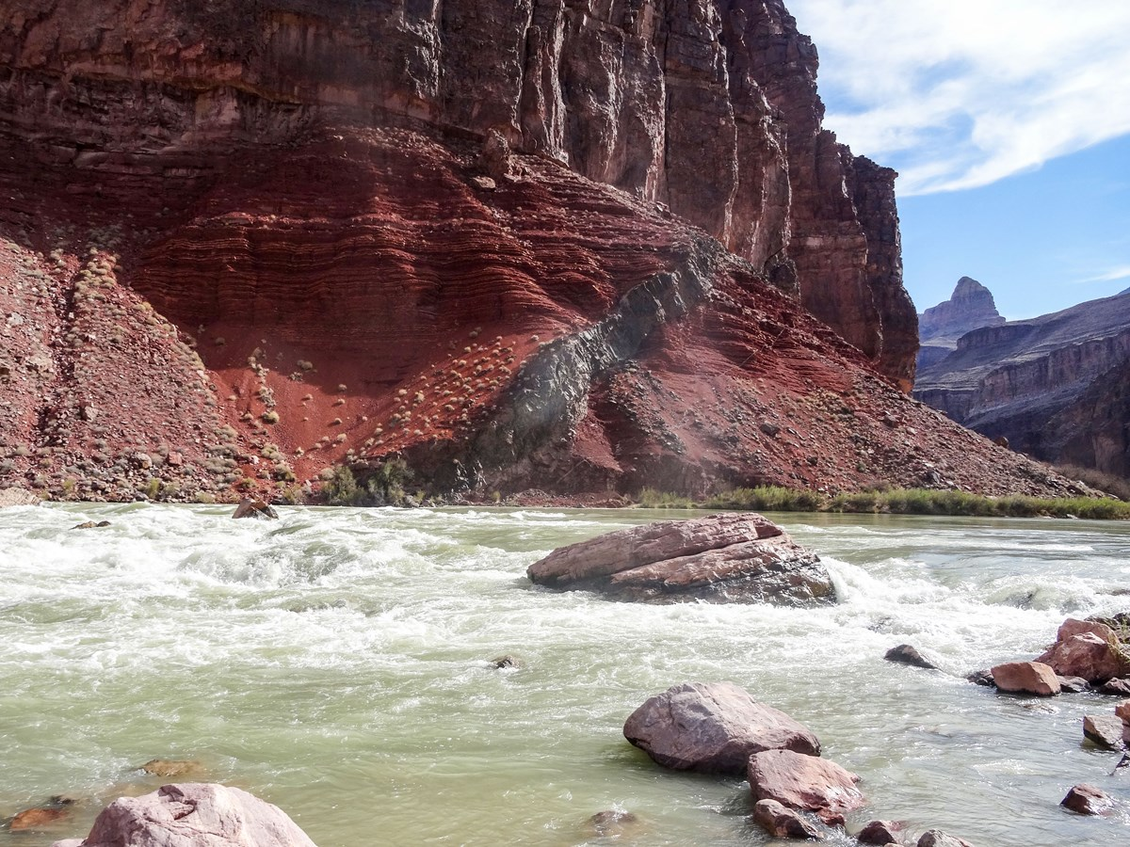

This is a picture from the bottom of the Grand Canyon. There are three different rock beds here… can you spot them? (Hint: look for differences in color, orientation, layers, and cliff-forming vs non-cliff forming.) What rocks do you think formed first? Which do you think formed last? How can we tell when each rock formed?

Lecture Questions
Follow along with the lecture and fill out these

- Law of Superposition
Create a time order sequence of your playdoh model.

- Original Horizontality
Create a time order sequence of your playdoh model.
1.
2.
3.
4.

- Cross-cutting Relationships
Create a time order sequence of your playdoh model.
1.
2.
3.
4.

- Unconformities
Create a time order sequence with your playdoh model.
1.
2.
3.
4.

Activity Questions

Put the layers and events from this diagram in relative time order.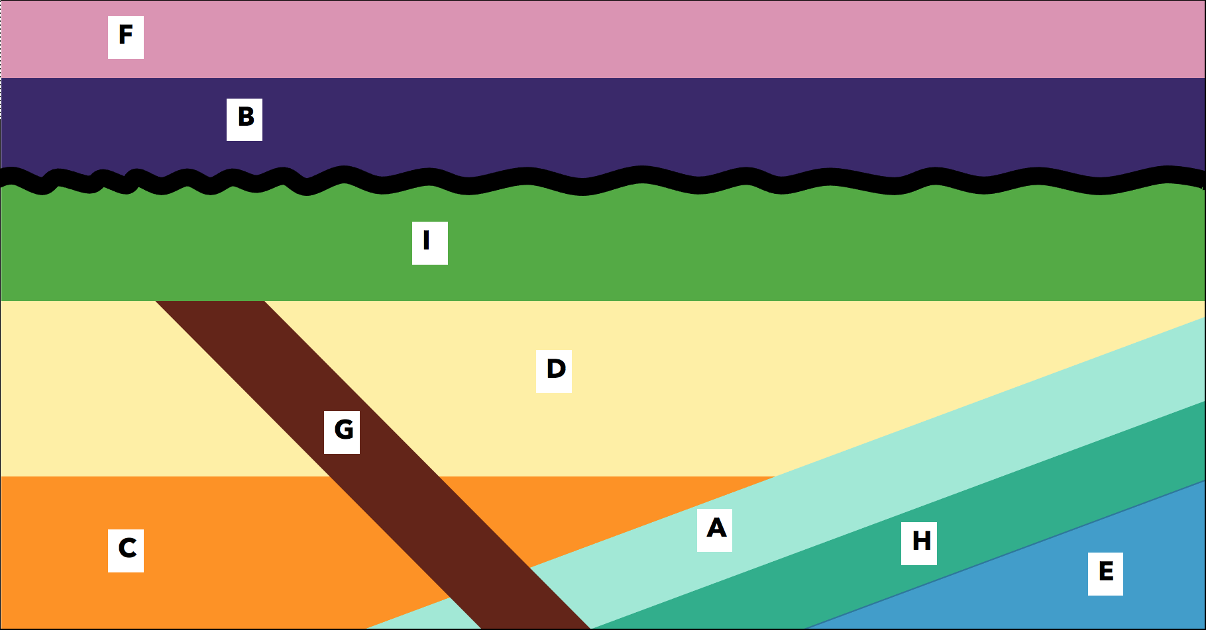

We have samples of some of the rock layers that help us figure out the environment they formed in. Check out the rocks at each station.
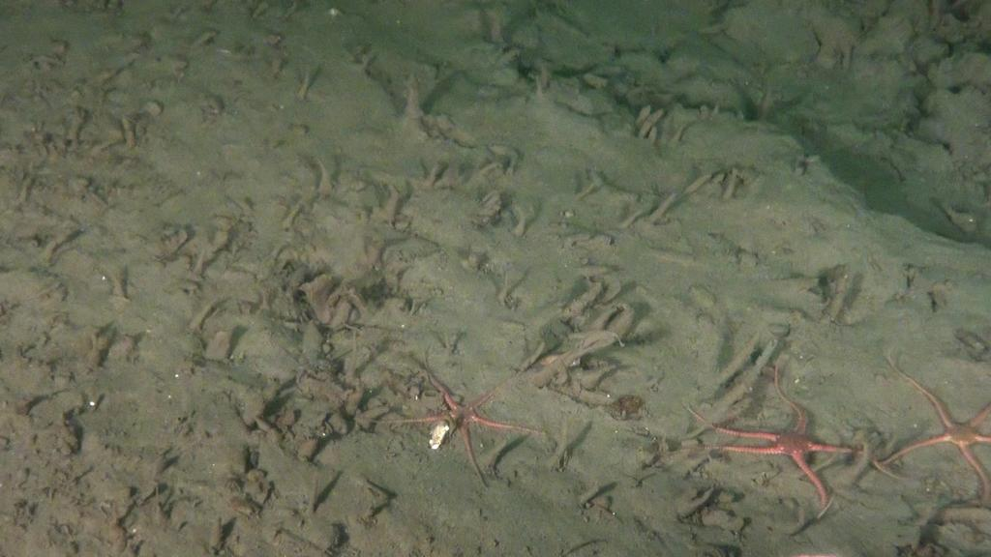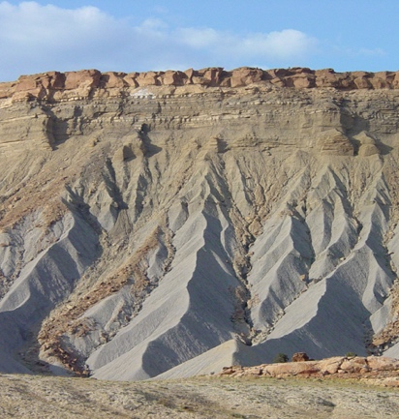
Rock H is a shale from the deep sea, with very small grains, and contains an ash layer dated at 135 million years old.

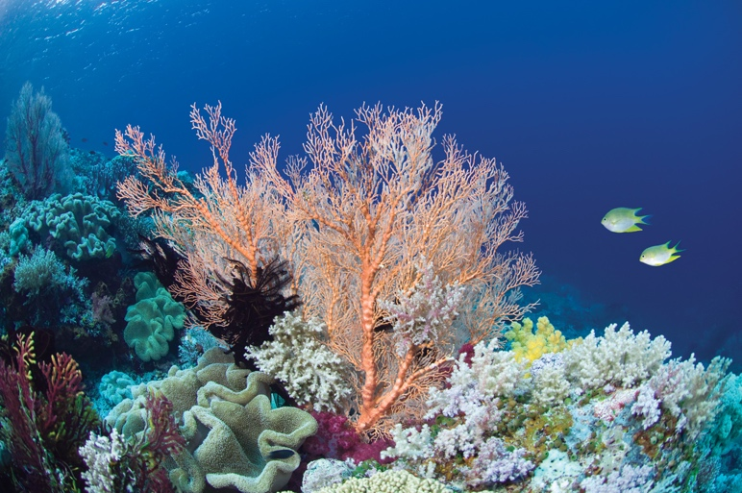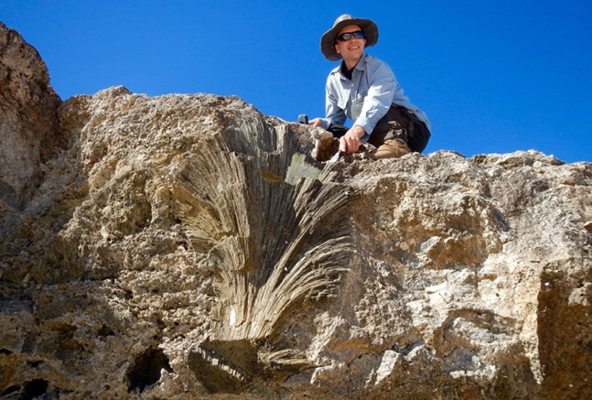
Rock A is a limestone from a reef in a shallow ocean (look for the little shell fossils!)
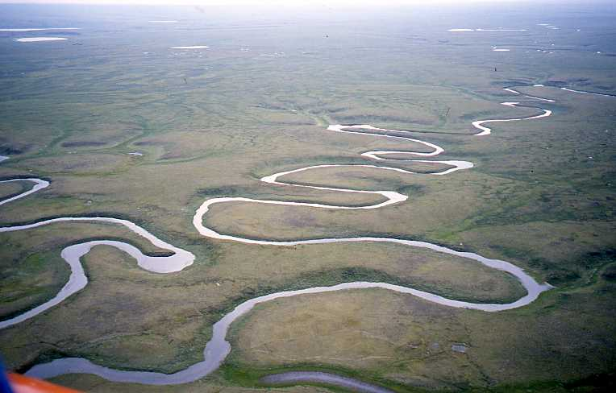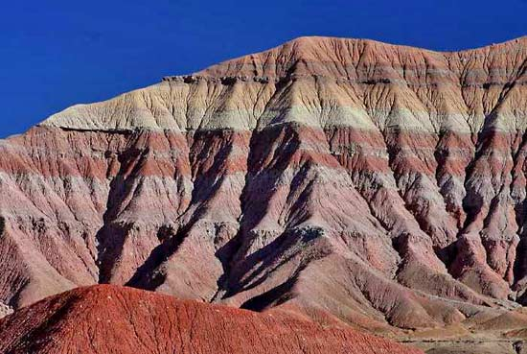

Rock I is a shale from a river floodplain.

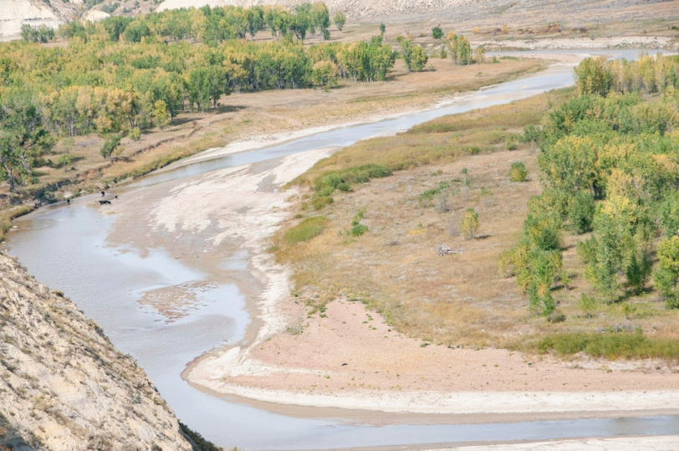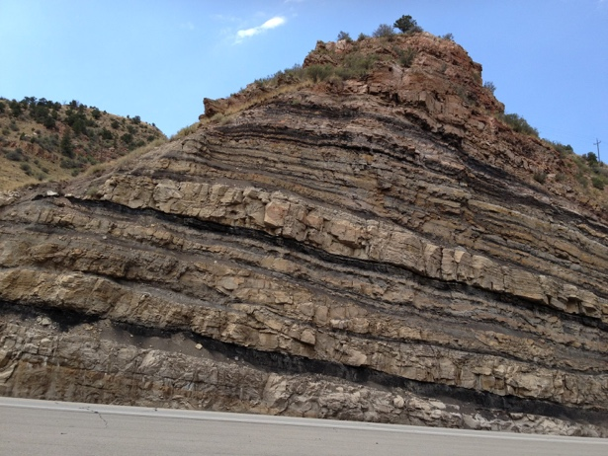

Rock D and Rock F are a sandstones from a river sandbar.

Rock G is basalt, a volcanic rock, and is dated 63 million years

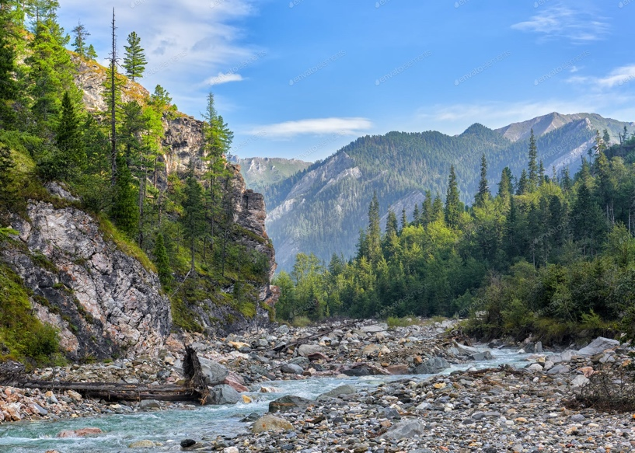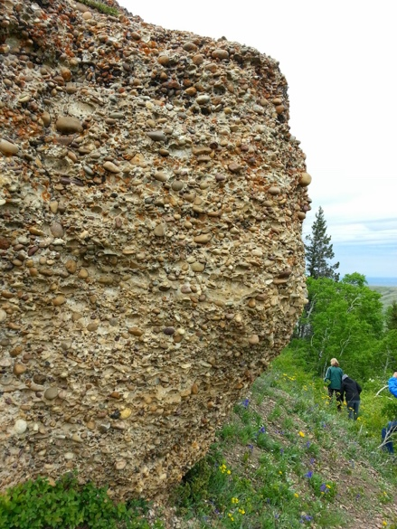
Rock C is a conglomerate from a mountain stream

Dinosaurs (except birds) lived on land between 240 million years ago and 66 million years ago. Terrestrial fossils are usually found in river sedimentary rocks that have sand-sized grains or smaller. Considering this information, the sedimentary environments from the rock samples, and your relative time order sequence, which rock layer would you target to find dinosaur fossils? Explain why.

