Name:
Date:

Human Impacts to the Water Cycle: The Colorado River
In this activity, you’ll learn about how humans can impact the natural water cycle, specifically by looking at how humans have altered the flow of the Colorado River. You have been provided with a packet of information about the Colorado River, including graphs of streamflow at six different locations from 2015 to 2020. These graphs give the amount of water moving through the Colorado River (in cubic feet per second) as a function of time. Use this information to answer the following questions:

1. The Colorado River originates in the mountains of Colorado, before flowing into Utah and then south to Arizona, Nevada, California, and finally Mexico. Examine streamflow at the six different locations along the river, and estimate an average value for streamflow at each site. Do you notice any increases or decreases in average streamflow as the river flows from its headwaters (where the river begins) towards Mexico? Discuss the trends you see.

Answer:

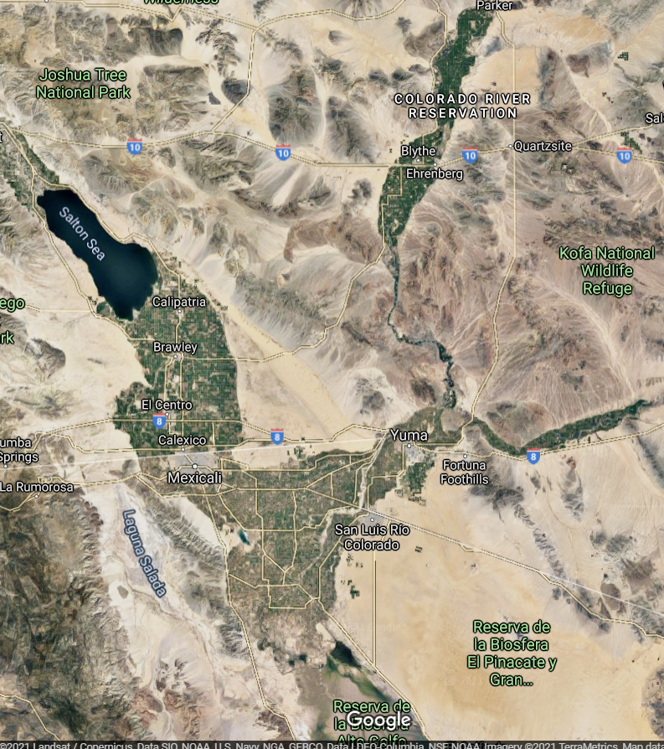

2. This is a satellite image of the Sonoran Desert in California, Arizona, and Mexico near the Colorado River. What are the green areas observed in this image (hint: how do we grow crops)? How are plants growing in this dry environment? Where are the plants getting their water from?

Answer:

3. In the first question, you likely observed that the amount of water in the Colorado River decreases as it flows south through California and Arizona towards Mexico. Why do you think this is? Is this caused by human activity? (Hint: think about the patchy green fields in the second question.)

Answer:

4. Several cities divert water from the Colorado River Basin for their water supply. These cities include Salt Lake City, Denver, Phoenix, Los Angeles, Las Vegas, Tucson, San Diego, and others (the river supplies water to nearly 40 million people).
You have been provided with some population graphs for Salt Lake City, Los Angeles, Phoenix, and Las Vegas. Are populations in these cities increasing or decreasing? How do you think that these current (and future) increases or decreases in population could impact the Colorado River? Will demand for Colorado River water increase or decrease?

Answer:

5. Look at the streamflow graph for the Colorado River at the Utah-Colorado state line. Why are there spikes (increases) in streamflow during the spring and early summer months? Why do some of these spikes vary in size from year to year?

Answer:

6. Based on the importance of snowpack in to the Colorado River Water supply, how do you think climate change may impact Colorado River streamflow?

Answer:

7.
a. Draw a graph showing Colorado River streamflow as a function of distance. In other words, draw a graph showing how Colorado River streamflow changes as it flows from its headwaters down to the US-Mexico border. Label your axes!
b. Draw a similar graph showing how you think the Colorado River would flow if humans did not divert water from the river.

