Definition: A fossil is evidence in rock of the presence of a life in the past.
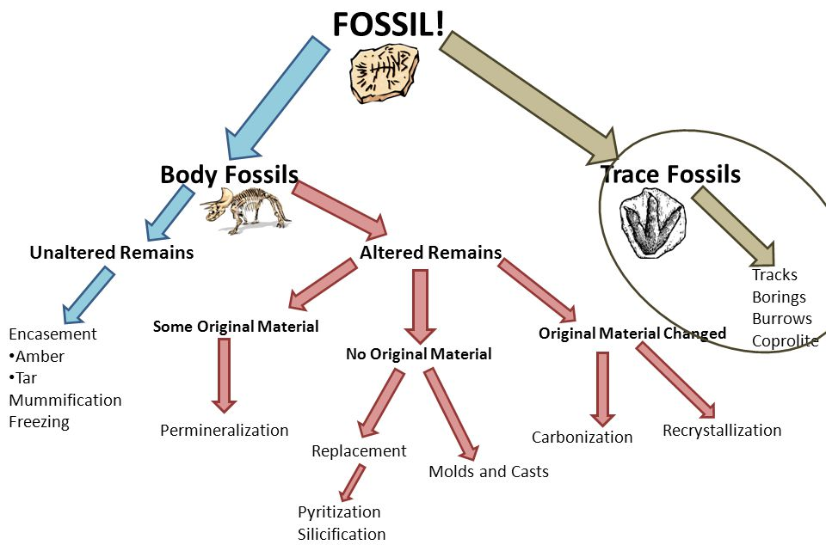

Fossil type | Description | Example
Trace | Imprints or material left from the activities of life: burrows, trails, foot prints, and poop! | 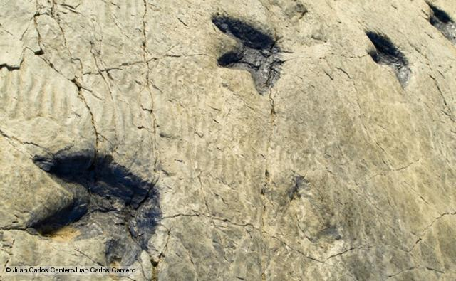
Body fossils
Unaltered remains (preservation of original material) | Encasement in amber or tar
 | Mummification or freezing
Permineralization | Minerals fill empty spaces | 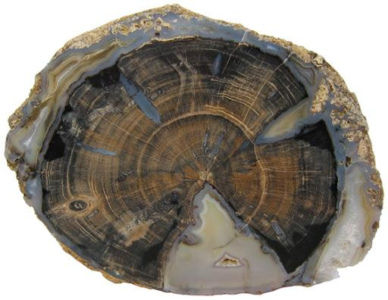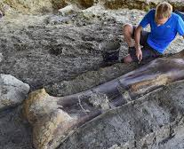
Mold and cast | Mold: mineralized impression of the organism left in the sediment.  Cast: mineralized sediment that fills the mold. | 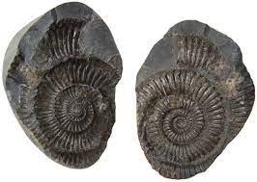
Replacement | Material dissolves and is replaced by a mineral. | 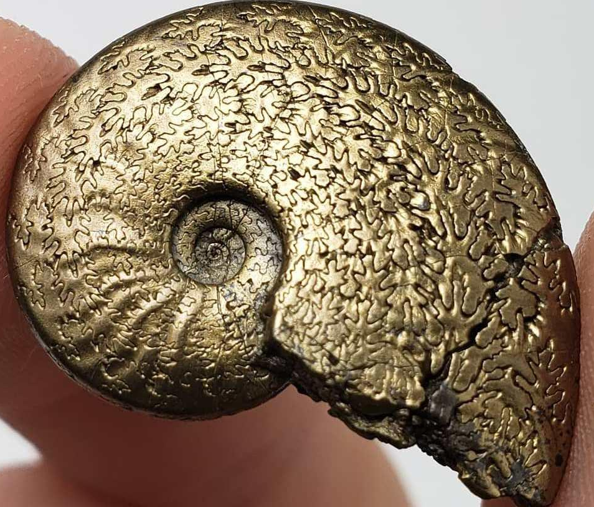
Carbonization | Only residual carbon remains as a thin black film. | 