We are visting the geology building on the University of Utah to learn about fossils today. We will learn the types of fossils, identify them, and see research laboratories and a college campus.

Station 1: Fossil not a Fossil
- Is a footprint a fossil? (circle one) yes no
Why? ________________________________________________________________

- Which of these is not a fossil?
- A dinosaur bone
- Poop that turned into rock (coprolite)
- A worm burrow
- A footprint
- An imprint of a leaf
- They are all fossils

- Could you extract dinosaur DNA from a bone? (circle one) yes no
Why? _______________________________________________________________________

Fossil identification activity
In front of you are different materials. Can you identify at least four samples that you think are fossils?
Sample | What type of fossil do you think this is? | What organism do you think created this?
1
2
3
4

Create a 2D “cast” fossil activity. Use a crayon or pencil to create a rubbing of a flat fossil.

Station 2: Fossils Building Tour

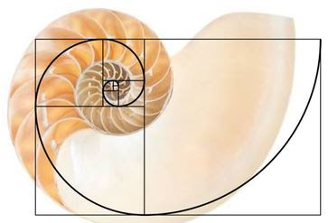
Observations vs. Inferences
An observation is based upon something you can sense or measure.
An inference is a conclusion based upon comparing observations with previous knowledge.

Example Stop
Observation 1. This thing has a spiral and multiple chambers.
Observation 2. The spiral is the same pattern as the golden ratio.
Inference: Because this resembles a seashell I saw before, I think it is a shell of a sea creature.

Stop 1
Observation 1. _______________________________________________________________
Observation 2. _______________________________________________________________
Inference ___________________________________________________________________

Fossil type? trace Permineralization mold & cast replacement carbonization

Stop 2
Observation 1. _______________________________________________________________
Observation 2. _______________________________________________________________
Inference ___________________________________________________________________

Fossil type? trace Permineralization mold & cast replacement carbonization

Stop 3
Observation 1. _______________________________________________________________
Observation 2. _______________________________________________________________
Inference ___________________________________________________________________

Fossil type? trace Permineralization mold & cast replacement carbonization

Stop 4
Observation 1. _______________________________________________________________
Observation 2. _______________________________________________________________
Inference ___________________________________________________________________

Fossil type? trace Permineralization mold & cast replacement carbonization
Stop 5
Observation 1. _______________________________________________________________
Observation 2. _______________________________________________________________
Inference ___________________________________________________________________

Fossil type? trace Permineralization mold & cast replacement carbonization

