Name:_________________ Group Color:_________________
Great Salt Lake State Park Field Trip
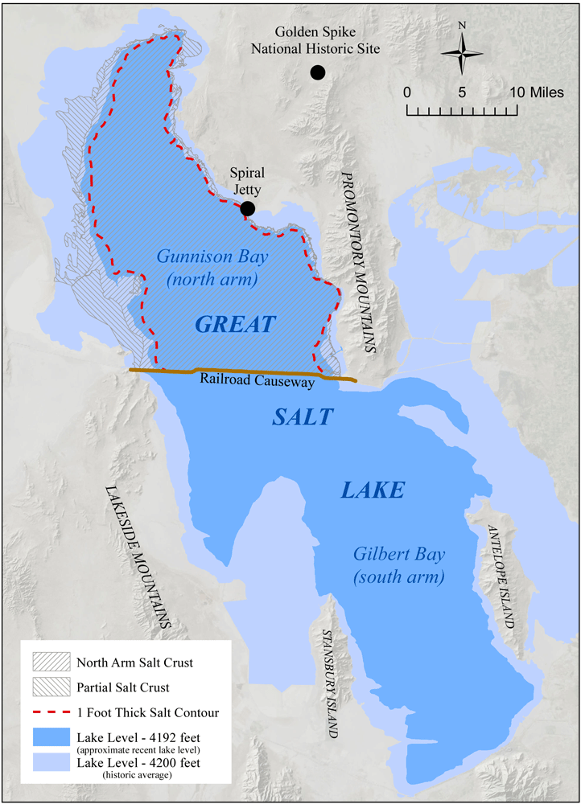
Schedule (subject to change):
9:45 – Arrive
- Station 10:00-10:25
- Station 10:30-10:55
- Station 11:00-11:25
- Station 11:30-11:55
- Station 12:00-12:25
12:25-1:00 – Lunch @ Pavilion
1:00 - Depart

Map Area (below)
Red
Yellow
Green
Blue
Orange
Great Salt Lake
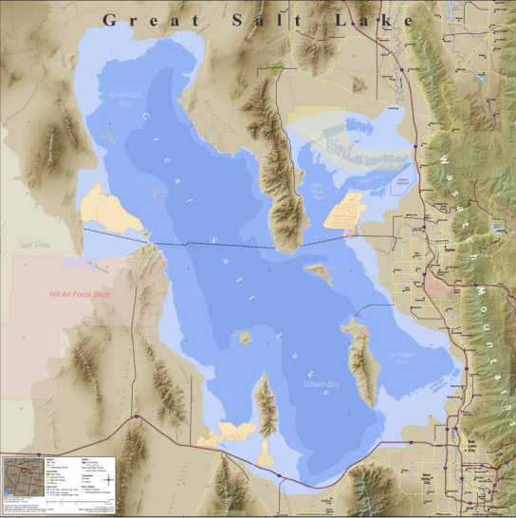
The Great Salt Lake is the largest lake west of the Mississippi River. It is one of the saltiest bodies of water in the world, and a remnant of the ancient freshwater Lake Bonneville, which once covered a third of the state of Utah. At its average level (4,200 ft above sea level), the Great Salt Lake is 75 miles long and 35 miles wide at its widest point. The lake is very shallow, with an average depth of only 14 feet. At its deepest, the lake is approximately 30 feet deep.
Antelope Island →
The lake is located at the bottom of a flat basin (the Great Basin). A slight rise in the lake's level results in a significant increase in the area of the lake. At its average level of 4,200 feet, the lake’s area is 1,700 square miles. In 1987 when the lake was at its highest level of 4,212 feet, the surface area increased to 2,400 square miles. At its historic low in 2021 (4,190 ft) the lake was half the size it reached in 1987. Since 1849, when the first scientific measurement of the lake was taken, the shoreline location has varied by as much as 15 miles!
There are eight official islands in the Great Salt Lake. During low lake levels, some of the islands become peninsulas. The islands were designated in 1875 when water levels were higher, and only eight islands were exposed. The islands range in size from 28,000-acre Antelope Island to 22-acre Hat Island.

Great Salt Lake State Park
This State Park provides boat slips, public viewpoints of the Great Salt Lake, sail and motorboat access, and a search and rescue operations center. The lake is two to seven times saltier than the ocean and is also a popular destination for bird watching as it is a major stop for millions of migratory birds.

Frequently Asked Questions
- How deep is the lake? Average: 14 feet Deepest: 30-40 feet
- What is the temperature of the lake? 70° F in the summer
- Why is Great Salt Lake Salty? There are no outlets in the Great Salt Lake. Rivers flow in, but the only way water leaves the lake is through evaporation. Minerals (such as salt) are left behind to accumulate.
- How Salty is the Great Salt Lake? Farmington Bay is 5% salinity, the South Arm is 8-15%, and the North Arm is 28%. The differences are due to freshwater flowing into the southern part of the lake and not being able to flow freely into the North Arm (due to the railroad causeway).
- How big is the Great Salt Lake? At its average level of 4,200 above sea level, the lake is 75 miles long and 35 mile wide at its widest point.
- Are there fish in the Great Salt Lake? No. Brine shrimp and brine flies live in the Great Salt Lake, and feed off of algae.
- What makes the lake stink? The unpleasant odor is caused by bacteria that live in low oxygen waters and sediments of Great Salt Lake. These bacteria, known as sulfate reducing bacteria, feed on dead plant and animal material (algae and brine shrimp) and generate large amounts of hydrogen sulfide, creating a “rotten-egg” smell.
- What animals live on Antelope Island? Bison (700), mule deer (500), pronghorn antelope (230), California bighorn sheep (120), coyotes, jackrabbits, cottontail rabbits, badgers, bobcats, kangaroo rats, mice, red fox, chukar partridge, lizards, and snakes (gopher, blue racer, garter – none of which are poisonous).
- Why are there so many birds? The Great Salt Lake is one of the most important avian breeding and migratory staging areas in the United States. The birds gorge on the plentiful brine shrimp and brine flies.

GEOLOGY Part I: What are those weird horizontal things?
Directions: look at the mountains to the south near the smokestack.
- Do you see any weird horizontal features on them? (circle one) yes no
- How many horizontal features do you see? (circle one) 0 1 2 3 4 5 6
- How high do you think the horizontal features are? (Fill in elevations below)
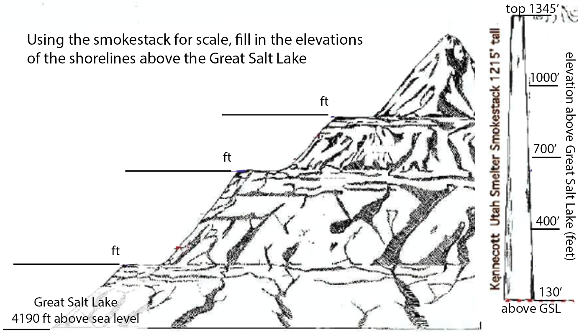

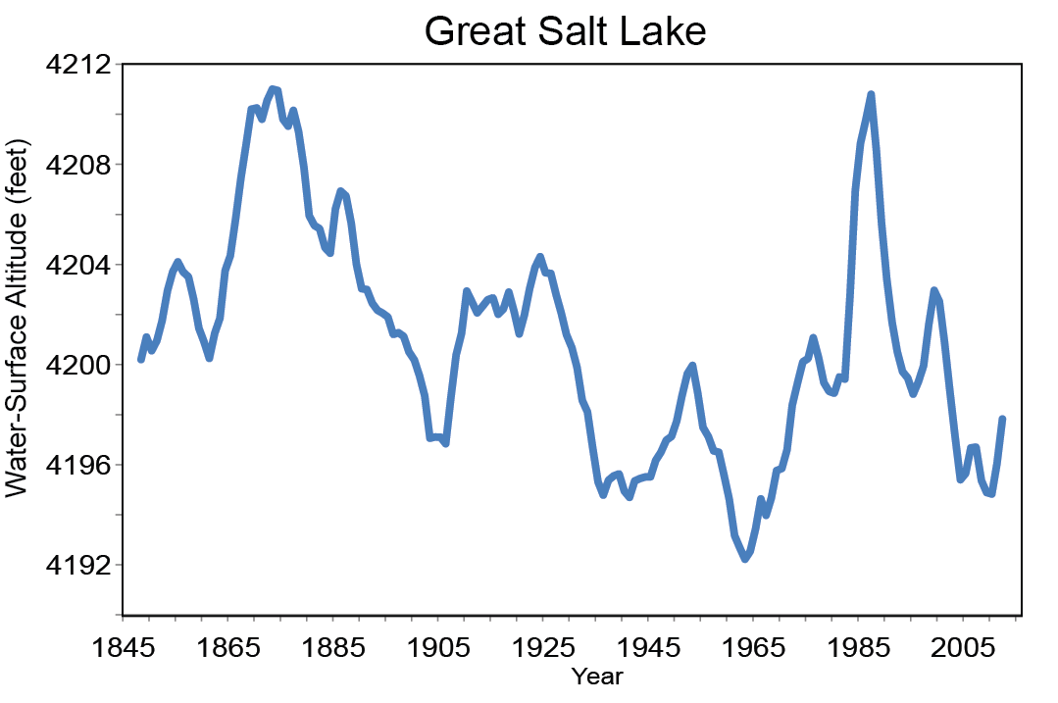
- What could have caused these horizontal features to form? ________________________

GEOLOGY Part II: modern Great Salt Lake
- The lake’s water level has fallen since it peaked at the level of the parking lot (4212 ft) in 1985. Where did the water go?
___________________________
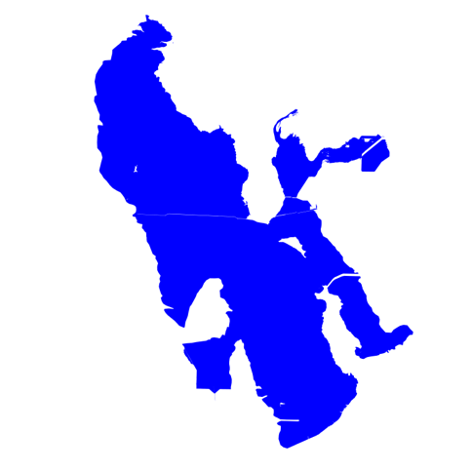
- Label the ways water goes in and goes out of the lake.

IN
OUT
IN

- What would cause the lake to grow? ________________________________

GEOLOGY Part III: What’s that sand made out of?
Directions: Describe the sands by sketching them and completing the table. Use the grain size and shape charts.
Grain Size Chart Grain Shape Chart
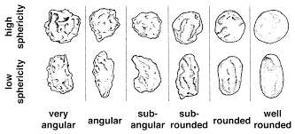
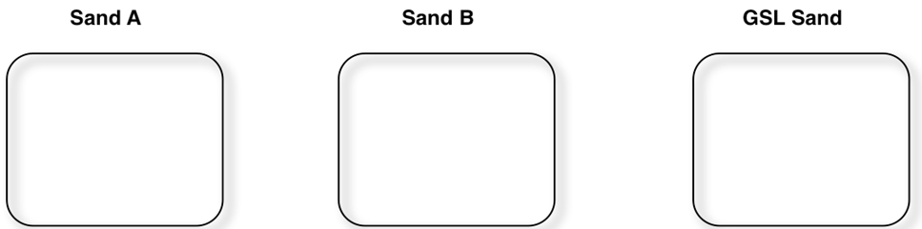

Sand | Color | Grain Size | Grain Shape
Sand A
Sand B
Great Salt Lake
- How is Great Salt Lake Sand different from the other sand? _______________________
- Great Salt Lake sand is made of ooids, what is at an ooids center? _________________

WEATHER Part I: Clouds
- Are there clouds? (circle one) Yes No

Use the chart to describe what kind of clouds there are (if present)
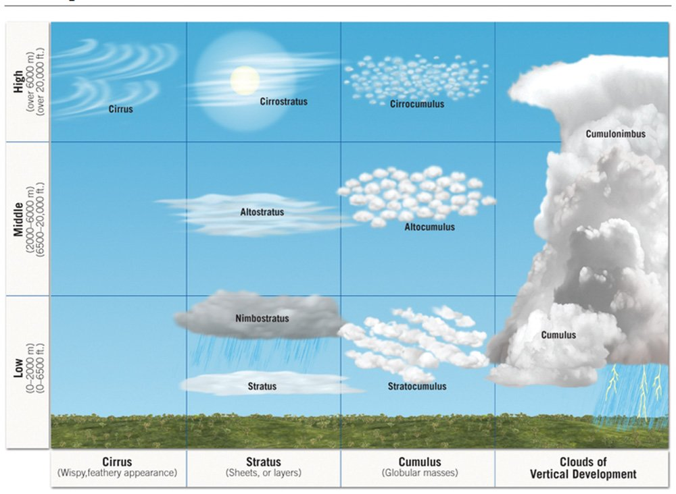

- Cloud elevation (circle one or more):
no clouds Low Middle High

- Cloud shape (circle one or more):
no clouds Cirrus (wispy) Stratus (sheets) Cumulus (puffy)

- What percent of the sky is clouds? (Circle One)
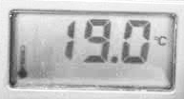
0-25% 25-50% 50-75% 75-100%

WEATHER Part II: Temperature
- Use a thermometer to make measurements and fill in the table below.
Location and material | Temperature (units _______)
Lake water
Air above lake water
Dry sand temperature
Dry sand temperature in the shade
Air temperature (on the beach between the lake and the parking lot)

WEATHER Part III: Wind
Use the handheld weather station for this activity

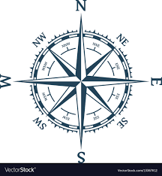
- What direction is the wind blowing in? (circle one)
If you stand so that the wind is blowing directly into your face, the direction you are facing names the wind.

No wind North East South West
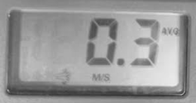

- Measure the wind speed and complete the table.
Location | Wind speed (meters per second, m/s)
Near lake water (knee level)
Near lake water (eye level)
On the beach between the lake and the parking lot (knee level)
On the beach between the lake and the parking lot (eye level)

- How did the windspeed change from:
- Near the water to away from the water (circle one)
↑ faster ↓slower same

- Knee level to eye level (circle one)
↑ faster ↓slower same

BIOLOGY Part I: Signs of life – Scavenger Hunt
DIRECTIONS: This station’s goal is to identify signs of life along the shores of Great Salt Lake. Do not stray away from your group. You will be provided with a hand lens and binoculars for wildlife viewing and a small plastic container for water sampling. Record your findings below!
Signs of life in the Water
Species/Object | Location | Count (many, few, one)

Signs of life along the shoreline
Species/Object | Location | Count (many, few, one)

Signs of life everywhere else
Species/Object | Location | Count (many, few, one)

BIOLOGY Part II: Brine shrimp observation
DIRECTIONS: During your signs of life scavenger hunt, you may have noticed many brine shrimp (that you also collected in small containers as part of the activity). Now it is time to look more closely – what are these shrimp doing? You will pick one brine shrimp in this station and watch it for 3 minutes. Keep track of what it is doing (swimming, staying still, interacting with other shrimp in the container, etc.) every 30 seconds. Record your findings in below!

Time | What is your brine shrimp doing?
30 seconds
1 minute
1.5 minutes
2 minutes
2.5 minutes
3 minutes

BIOLOGY Part III: Bird Observation
DIRECTIONS: During your signs of life scavenger hunt, you may have seen some birds! Pick out one bird, just like with the brine shrimp, observe the bird for three minutes and record its behavior. Use the provided binoculars if needed.

Time | What is your bird doing?
30 seconds
1 minute
1.5 minutes
2 minutes
2.5 minutes
3 minutes

Density: Are you DENSE?
1. What is VOLUME?
2. What is MASS?
3. What is DENSITY?
Material | Mass  (g) | Volume  (cm³) | Density  (g/cm³) | Does this object float in pure water? | Does this object float in the Great Salt Lake?

4. What do you think determines why something floats or sinks in water? Form a hypothesis based on your exploration today. _____________________________________________________________________________
_____________________________________________________________________________

