For Field Trip Organizers
Summary
There are three stations in this field trip. We suggest 20-30 minutes/station. Stations could be added or removed. Potential additional stations include 1) Earth Science and Mining games (mineral matching, rice mining) and 2) seismological station lesson. The current field trip is focused upon fossils. This template can be adjusted to focus on other geological concepts, such as rocks and minerals; there are samples and large stone slabs that are well suited to this.

Station summary
- Classroom Fossil Identification
- Building Tour
- Campus Tour

Station 1. Fossil Types Identification
Reserve a classroom, use presentation, fossil types overview sheet in this packet, and the “Fossil not a Fossil” activity boxes.

Station 2. Building Tour
Take 2 minutes to look at the features at each stop. Instruct students to write down observations about the feature. Discuss these observations. Now discuss what you think those observations mean (inferences).
Suggested stops
Third floor stops
- The slabs with many fossils near the department office
- Fossil wall across from the bathroom (activity: sketch a cephalopod [wax paper and pencil]) (Stop 1)
- Mass mortality wall - death traps make for great fossil accumulations. (Stop 2)
- Enjoy the view over the city (take a look at the casts of ammonoid fossils on the wall)
Second floor stops
- Footprints and carbonized mold and cast across from bathrooms (Stop 3)
- Leaf and fish fossils near confluence (Stop 4)
- WBB labs and coffee shop
First floor
- Seismology station – check out if an earthquake has happened recently. Have the students jump together to make an earthquake. It will be reported on this screen (red square).
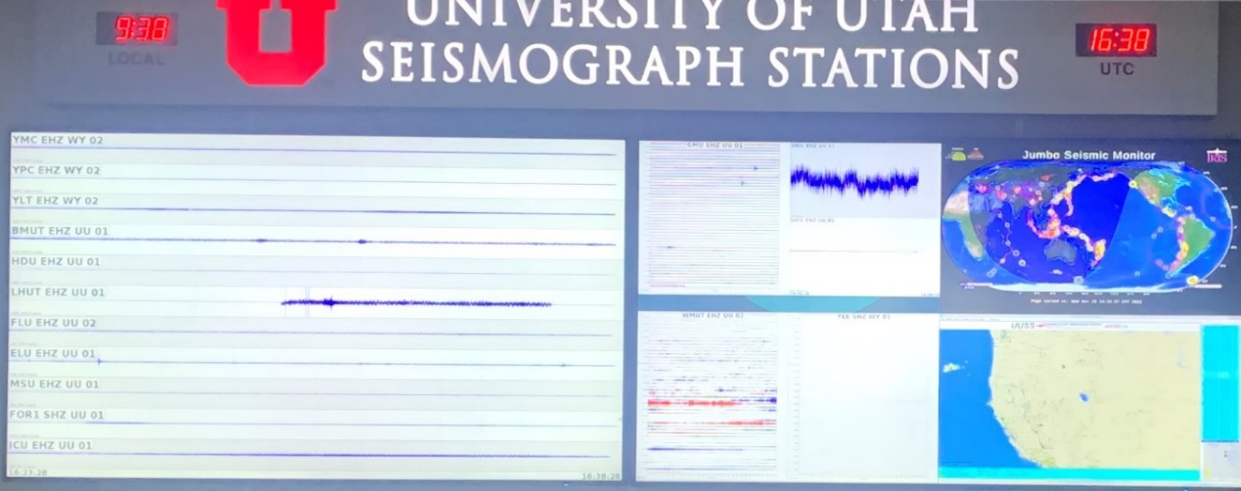
- Fossils in the collection (popular spot): coprolite, fossilized wood, the fine delicate fossils, dinosaur bone, T-rex skull. (Stop 5)
- Outside rock pile (this was popular with students) (Finish here before heading on campus tour)

Station 3: Campus exploration
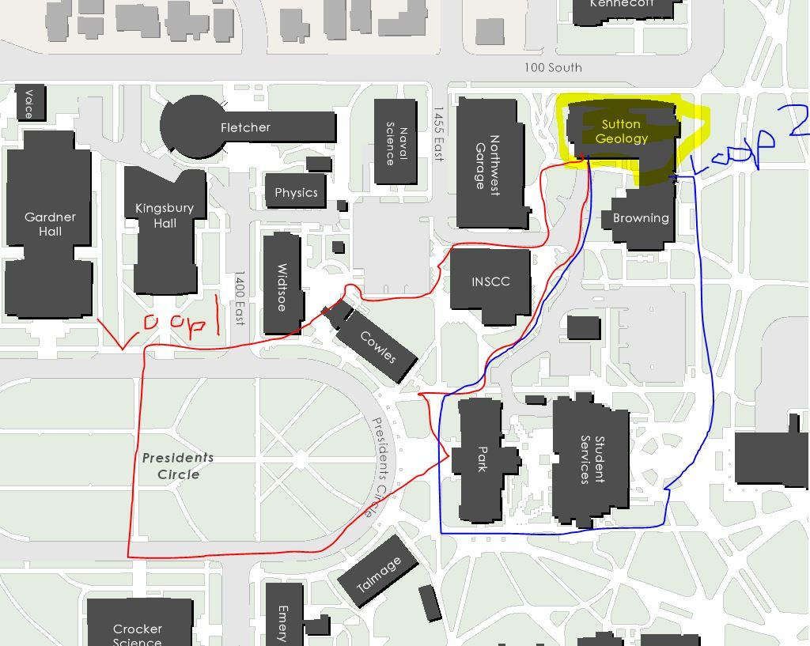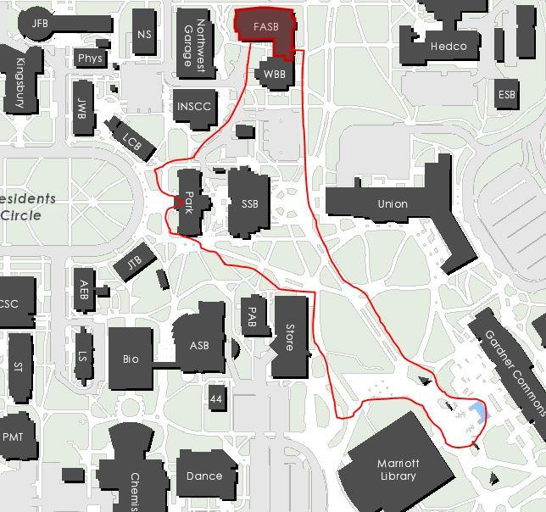
Loop 3
Loop 1
Loop 2
Potential Stops (https://admissions.utah.edu/virtual-campus-tour/)
- Rock Garden next to FASB
- Park building – good photo spot
- President’s circle and Kingsbury Hall – site of 2020 VP debate.
- Marriott Library
- The student union
Fun facts
- 1500 acres and 32,000 students
- President’s circle – buildings named after former U of U presidents, first buildings on campus.
- Football stadium hosted 2002 Winter Olympics
- Kingsbury Hall: Local performing arts companies such as the Utah Symphony, Utah Opera, Ballet West, and Repertory Dance Theatre started in Kingsbury Hall.
- Marriot Library –you can check out books, computers, and skeletons! (And there are 3D printers)
- U. art Museum – 20,000 pieces of art
- Block U –popular photo spot
- Gardner Commons – geothermal heating system – one of the newest campus buildings
- Student Union – learning abroad, LGBTQ center, Veterans’ Affairs, there is a bowling alley too!

Potential questions for guides to ask students!
      - Do you know anyone who went to the U of U?
      - What do you think students do?
      - What do you think professors do?
      - What kind of research do you think is done here?

